**MATLAB EXERCISE -6**

Anusha Garg

RA21110470232

**QUESTION1:**  Try outs : x= [ 1 2 5]; y= [2 3 4]; z=[7 8 9] -- (1,2,7 ; 2,3,8; 5,4,9 ) include : z label.

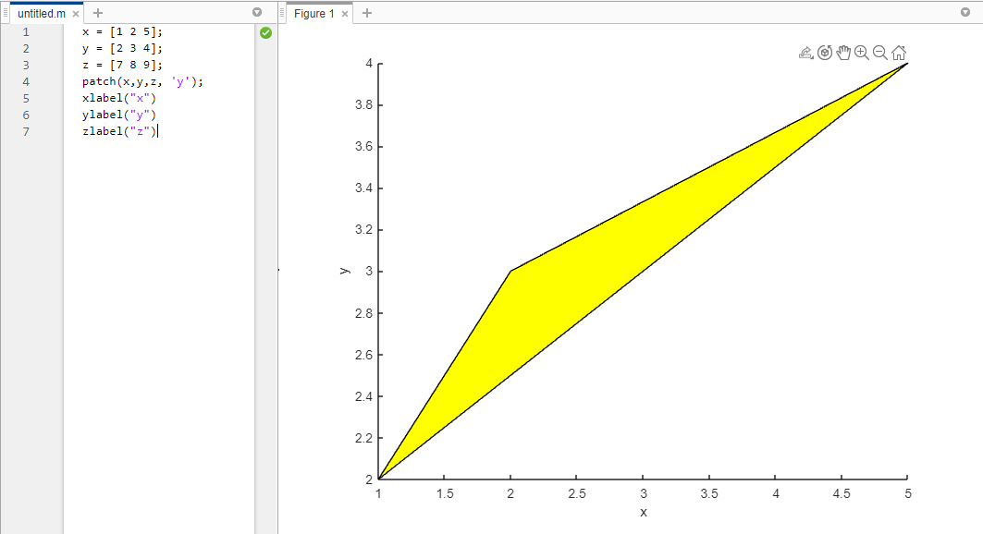

**QUESTION** : 2 t=linspace(0,6*pi,30); x=3*cos(t); y=1*sint(t) ; z= 0.01*t .^2; Use plot3(x,y,z) or plot3(x,y,z,’mo’).

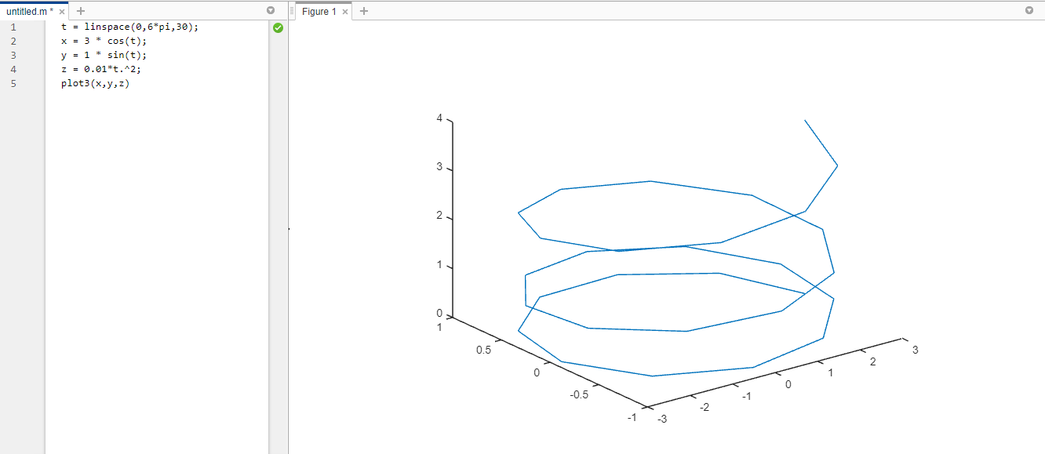

**QUESTION : 3** Scatter3 : Replace scatter3 in the place of plot3 and infer the difference**.**

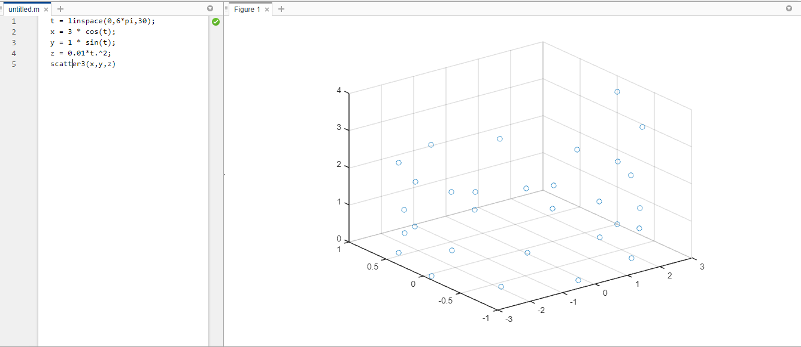

**QUESTION :** 4 In the above replace x,y and z with the following :

x=linspace(-pi,pi,20);

y=linspace(-10,16,30);

z=cos(X1) . * cos(X2);

Patch :

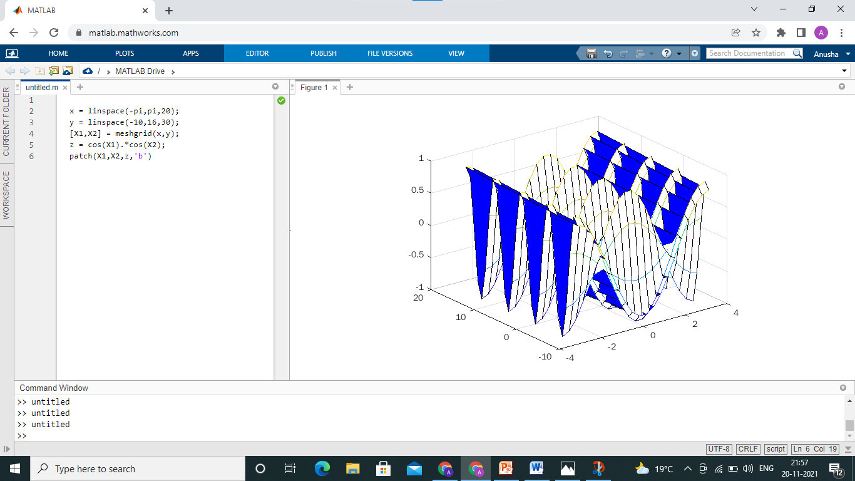

Mesh:

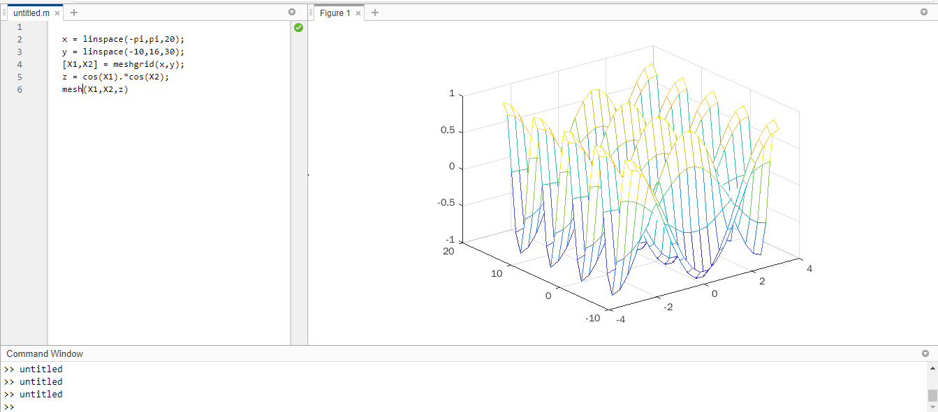

**QUESTION : 5** Replace the mesh function with contour, surface, surfc for the above mentioned data.

Contour :

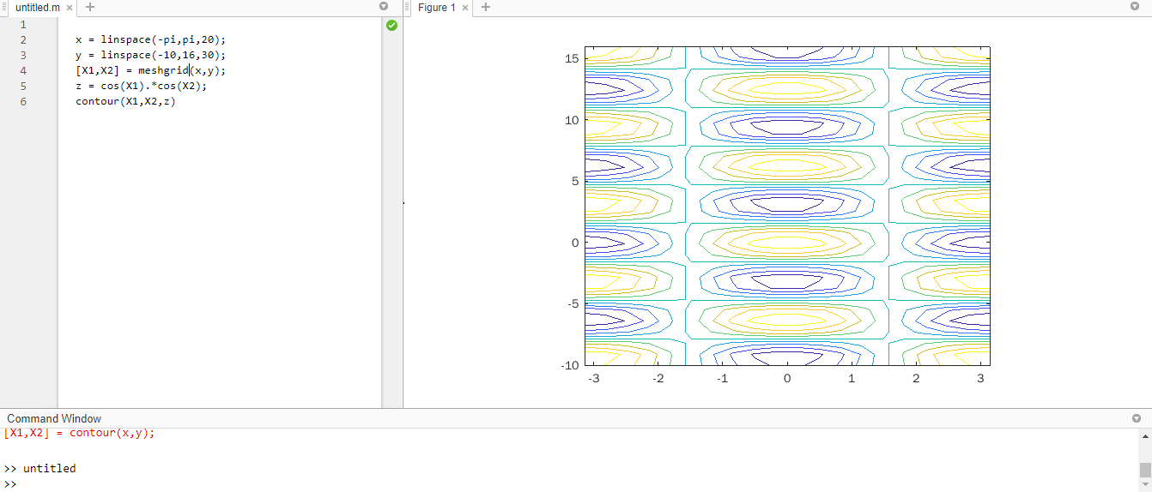

Surface :

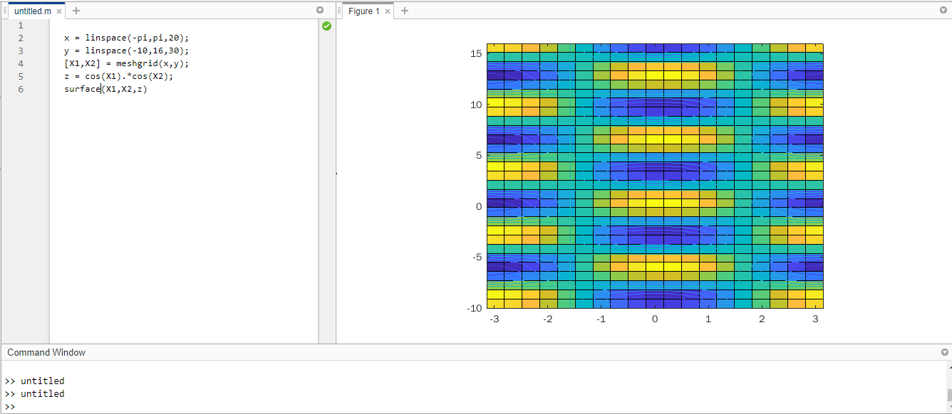

Surfc :

